MORNING WORSHIP SERVICE
Dec 27, 2015

Opening Song “When We All Get To Heaven” 514

Opening Prayer/Announcements

Worship Hymns “He Keeps Me Singing” 425
“Blessed Assurance, Jesus Is Mine” 334
“Leaning on the Everlasting Arms” 333
“Jesus Is the Sweetest Name I Know” 205
“There’s Something About That Name” 177

Offering/Offertory

Special Music

Message Bro. David Atwood

Invitation “I Have Decided To Follow Jesus” 305

Living Proof Live
March 4-5, 2016 (Fri & Sat)
Waco, TX: Extraco Event Center
Contact Patti Radford if you might be interested in attending

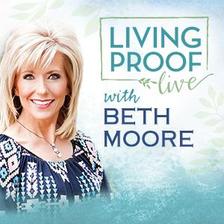

Closing Prayer

Evening Service 6:00

NURSERY – available for children age 0 to Kindergarten
Patti Radford

Hostesses for December Ushers for December
Dianne Lindemann, Shelia Waggoner, Kenny Merrell, Jimmy Miller,
Michael & Peggy Hammonds Wayne Marecle, Joe Daniel

Immediate Need Prayer List
Prayer & Request Information

(Please complete name & address information on reverse side)

❑ I would like to speak with the Pastor.

❑ I would like more information on this church.

❑ I have Prayer Requests or Needs

Date:

Permission to Publicize:
Church Bulletin  Yes  No
Email Prayer Chain  Yes  No

Prayer Request:

Prayer For
Name
Address
Phone

Given By
Name
Address
Phone
Please Contact By

❑ Card  Phone  Visit

Comments

Pray for Bobby and Judy Coffey

Pray for Jerry Watkins (friend of Hugo Breithaupt) – He is dealing with cancer

Pray for the family of Lorena Beauchamp

K s b c

Keeping His Word through Sunday School, Bible Study and Church Attendance/Worship

Sunday School Bible Studies for December:

Dec. 6th Adopted into God’s Family 1 John 3:1-10 Dec. 13th Freed by God’s Forgiveness John 8:2-11 Dec. 20th Saved by God’s Son John 1:1-5,9-14 Dec. 27th Strengthened by God’s power Ephesians 3:14-21

9:45 a.m. each Sunday – A place for everyone

WE’D LOVE FOR YOU TO JOIN US!

